Write a Custom Post Authentication Handler

Introduction

WSO2 Identity Server authentication framework facilitates you with the pluggable architecture of multiple inbound/outbound protocols as well as local and federated authenticators including a large number of extension points. The Post Authentication Handler is one such extension point which allows you to do a task upon successful authentication. Authentication to the system is only successful once the execution of post-authentication handlers is completed.

To demonstrate this, we will implement a post authenticator which will request your consent for retrieving user information from WSO2 IS to the service provider, upon successfully passing the authentication steps. The behavior of this post-authentication handler is,
- A consent page will be popped up upon successfully passing the authentication steps.
- If you click on approve, then you will be redirected to your application with a successful login
- If you deny the consent, authentication will be failed and you will be shown an error message on the screen.

Write an event handler
Follow the steps given below to write the handler.

- To write a new event handler, you must extend org.wso2.carbon.identity.application.authentication.framework.handler.request.AbstractPostAuthnHandler.
package org.wso2.carbon.identity.custom.post.authn.handler.disclaimer;

public class DisclaimerPostAuthenticationHandler extends AbstractPostAuthnHandler {

- Override the following methods accordingly:

private String CONSENT_POPPED_UP = "consentPoppedUp";

@Override
public PostAuthnHandlerFlowStatus handle(HttpServletRequest httpServletRequest,
HttpServletResponse httpServletResponse,
AuthenticationContext authenticationContext)
throws PostAuthenticationFailedException {

if (getAuthenticatedUser(authenticationContext) == null) {
return PostAuthnHandlerFlowStatus.SUCCESS_COMPLETED;
}

if (isConsentPoppedUp(authenticationContext)) {
if (httpServletRequest.getParameter("consent").equalsIgnoreCase("approve")) {
return PostAuthnHandlerFlowStatus.SUCCESS_COMPLETED;
} else {
throw new PostAuthenticationFailedException("Cannot access this application : Consent Denied",
"Consent denied");
}
} else {
try {
httpServletResponse.sendRedirect
(ConfigurationFacade.getInstance().getAuthenticationEndpointURL().replace("/login.do", ""
) + "/disclaimer" + ".jsp?sessionDataKey=" + authenticationContext.getContextIdentifier() +
"&application=" + authenticationContext
.getSequenceConfig().getApplicationConfig().getApplicationName());
setConsentPoppedUpState(authenticationContext);
return PostAuthnHandlerFlowStatus.INCOMPLETE;
} catch (IOException e) {
throw new PostAuthenticationFailedException("Invalid Consent", "Error while redirecting", e);
}
}
}

@Override
public String getName() {

return "DisclaimerHandler";
}

private AuthenticatedUser getAuthenticatedUser(AuthenticationContext authenticationContext) {

AuthenticatedUser user = authenticationContext.getSequenceConfig().getAuthenticatedUser();
return user;
}

private void setConsentPoppedUpState(AuthenticationContext authenticationContext) {

authenticationContext.addParameter(CONSENT_POPPED_UP, true);
}

private boolean isConsentPoppedUp(AuthenticationContext authenticationContext) {

return authenticationContext.getParameter(CONSENT_POPPED_UP) != null;
}

- Use handleEvent() method to do the actual operation.
The parameters related to the user operations can be taken from the event.getEventProperties() method.
public void handleEvent(Event event) {

if (IdentityEventConstants.Event.PRE_ADD_USER.equals(event.getEventName())) {
String tenantDomain = (String) event.getEventProperties().get(
IdentityEventConstants.EventProperty.TENANT_DOMAIN);
String username = (String) event.getEventProperties().get(IdentityEventConstants.EventProperty.USER_NAME);
log.info("Handling the event before adding user: " + username + " in tenant domain: " + tenantDomain);
// You can write any code here to handle the event.
}

if (IdentityEventConstants.Event.POST_ADD_USER.equals(event.getEventName())) {
String tenantDomain = (String) event.getEventProperties()
.get(IdentityEventConstants.EventProperty.TENANT_DOMAIN);
String userName = (String) event.getEventProperties().get(IdentityEventConstants.EventProperty.USER_NAME);
log.info("Handling the event after adding user: " + userName + " in tenant domain: " + tenantDomain);
// You can write any code here to handle the event.
}
}

- Register the event handler.
The event handler needs to register in the service component as follows:
package org.wso2.carbon.identity.custom.post.authn.handler.disclaimer.internal;

public class DisclaimerPostAuthnHandlerServiceComponent {

private static final Log log = LogFactory.getLog(DisclaimerPostAuthnHandlerServiceComponent.class);

@Activate
protected void activate(ComponentContext context) {

try {
DisclaimerPostAuthenticationHandler disclaimerPostAuthenticationHandler =
new DisclaimerPostAuthenticationHandler();
context.getBundleContext().registerService(PostAuthenticationHandler.class.getName(),
disclaimerPostAuthenticationHandler, null);

} catch (Throwable e) {
log.error("Error while activating disclaimer post authentication handler.", e);
}
}

Prerequisite
- A WSO2 Identity Server setup.
- Please verify that all the system requirements are satisfied.
- An Application registered in Identity Server.
- An application deployed in Tomcat server.
Ex: pickup-dispatch application

Set up
The existing implementation of a post authentication handler can be found from here.
- Clone wso2/samples-is repository and navigate to the etc/sample-post-authentication-handler directory.
cd etc/sample-post-authentication-handler

- Run the following command:
mvn clean install

- Copy the generated jar file into the <IS_HOME>/repository/components/dropins directory.
- Copy the disclaimer.jsp file inside the resources folder of this project into <IS_HOME>/repository/deployment/server/webapps/authenticationendpoint/ directory.
- To configure the event handler, add the event handler configuration to the <IS_HOME>/repository/conf/deployment.toml file.
The events that need to subscribe to the handler can be listed in subscriptions.
[[event_listener]]
id = "custom_post_auth_listener"
type = "org.wso2.carbon.identity.core.handler.AbstractIdentityHandler"
name = "org.wso2.carbon.identity.post.authn.handler.disclaimer.DisclaimerPostAuthenticationHandler"
order = 899

- Restart the Identity Server.

Try it

- Go to http://localhost.com:8080/pickup-dispatch and add your user credentials and Sign In.

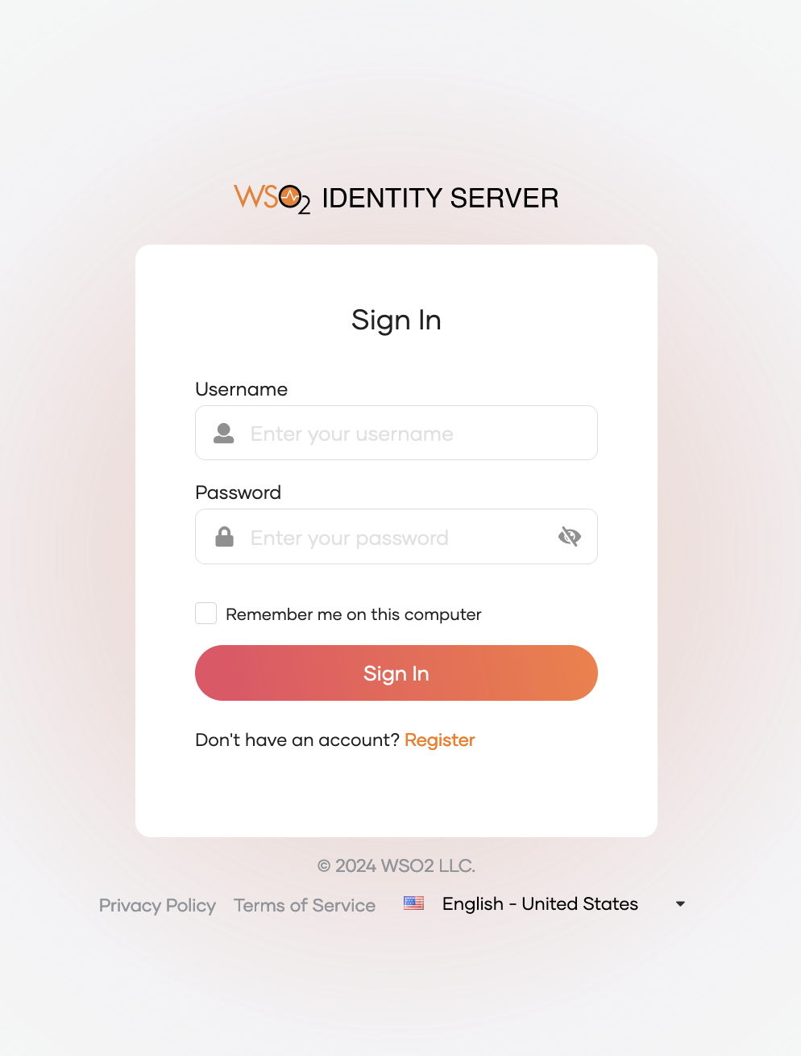

- Upon successful authentication, you will be prompted to a consent page giving the below message.